Panay Avenue corner Timog Avenue Quezon City, Quezon City, 1128 Metro Manila

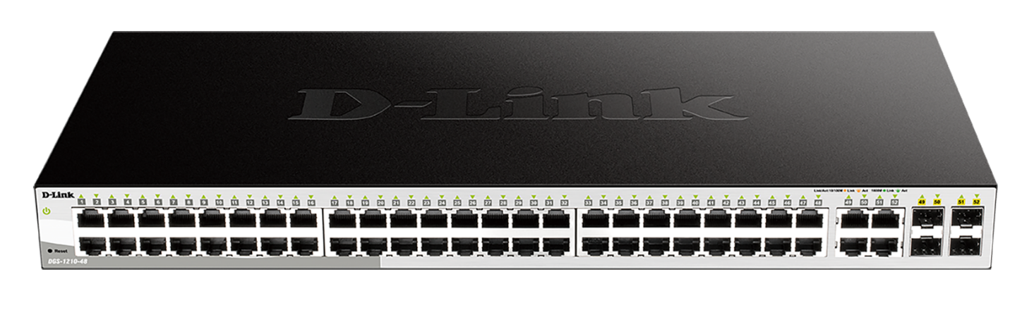 **LAYER 2 CONFIGURATIONS**

DISTRIBUTION CONFIGURATIONS 192.168.10.3  
1) CREATE VLAN 1,10,11,12,20,30,40

2) CREATE GROUP 2 LACP MODE ACTIVE PORT # 17,18,19,20 (TRUNK to ACCESS SW VLAN 20)

3) VLAN 2O AND OTHER VLAN TAGG AS TRUNK PORT LACP (17,18,19,20)  
4) CREATE GROUP 1 LACP MODE ACTIVE PORT # 45,46,47,48,49,50,51,52 (TRUNK TO CORE )

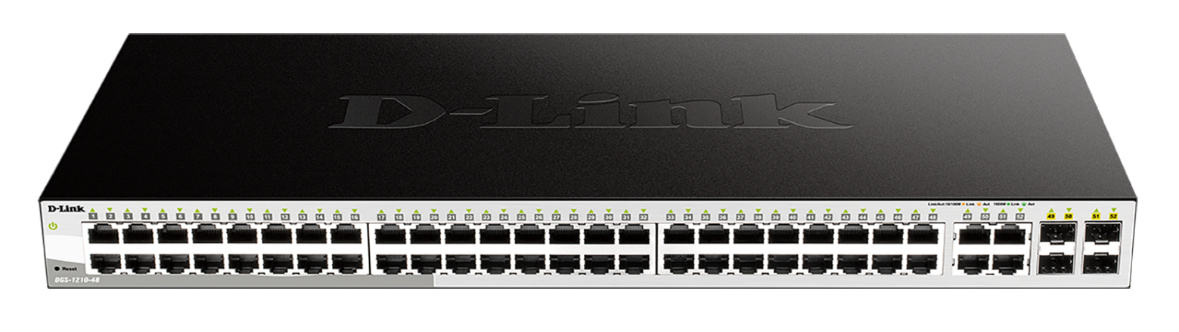1.1-PORT 17 LACP TRUNK CONNECTED TO PORT 51 LACP TRUNK (ACCESS SWITCH TO VLAN 20 )

ACCESS SWITCH FOR VLAN 20 CONFIGURATION 192.168.10.5

1. CREATE VLAN 1,10,11,12,20,30
2. ASSIGN PORT TO VLAN 20 (UNTAGGED) INTERFACE 5 to 48 ports
3. INTERFACE VLAN 20 or OTHER VLAN (TAGGED) PORT 51,52 AS TRUNK LACP
4. CREATE GROUP 1 LACP MODE ACTIVE (TRUNK) PORT # 51,52 (TRUNK TO DISTRI)

PREPARED BY: JOHN MARK RELLON  
 SUPPORT